Date: 2023-04-12
ISO/DIS 16132:2023(E)
ISO/TC 5/SC 2/WG 24
Secretariat: AFNOR
Ductile iron pipes and fittings — Seal coats for cement mortar linings
Tuyaux et raccords en fonte ductile — Seal coats pour les revêtements de mortier de ciment
© ISO 2023
All rights reserved. Unless otherwise specified, or required in the context of its implementation, no part of this publication may be reproduced or utilized otherwise in any form or by any means, electronic or mechanical, including photocopying, or posting on the internet or an intranet, without prior written permission. Permission can be requested from either ISO at the address below or ISO's member body in the country of the requester.
ISO Copyright Office
CP 401 • CH-1214 Vernier, Geneva
Phone: + 41 22 749 01 11
Email: copyright@iso.org
Website: www.iso.org
Published in Switzerland.
Contents Page
Foreword 4
Introduction 5
1 Scope 1
2 Normative references 1
3 Terms and definitions 1
4 Materials in contact with water intended for human consumption 2
5 Performance test requirements 2
5.1 Short-term sealing efficiency 2
5.2 Long-term sealing efficiency 2
5.3 Cyclic pressure 2
6 Routine test requirements 3
6.1 General 3
6.2 Visual appearance 3
6.3 Coating thickness 3
6.4 Adhesion 3
7 Marking 3
Annex A (normative) Short-term sealing efficiency 4
A.1 Principle 4
A.2 Materials 4
A.3 Apparatus 4
A.4 Preparation of test samples 4
A.5 Procedure 4
Annex B (normative) Long-term sealing efficiency 6
B.1 Principle 6
B.2 Materials 6
B.3 Apparatus 6
B.4 Preparation of test samples 6
B.5 Procedure 7
Annex C (normative) Cyclic pressure test 9
C.1 Principle 9
C.2 Apparatus and material 9
C.3 Sample preparation 9
C.4 Procedure 9
Annex D (normative) Coating thickness measurement using test film 11
D.1 Principle 11
D.2 Apparatus 11
D.3 Preparation of test samples 11
D.4 Micrometer measurement method 11
D.5 Weight and area method — Procedure 12
Annex E (normative) Adhesion test 13
E.1 Principle 13
E.2 Apparatus 13
E.3 Procedure 13
Bibliography 16

Foreword
ISO (the International Organization for Standardization) is a worldwide federation of national standards bodies (ISO member bodies). The work of preparing International Standards is normally carried out through ISO technical committees. Each member body interested in a subject for which a technical committee has been established has the right to be represented on that committee. International organizations, governmental and non-governmental, in liaison with ISO, also take part in the work. ISO collaborates closely with the International Electrotechnical Commission (IEC) on all matters of electrotechnical standardization.
The procedures used to develop this document and those intended for its further maintenance are described in the ISO/IEC Directives, Part 1. In particular the different approval criteria needed for the different types of ISO documents should be noted. This document was drafted in accordance with the editorial rules of the ISO/IEC Directives, Part 2 (see www.iso.org/directives).
Attention is drawn to the possibility that some of the elements of this document may be the subject of patent rights. ISO shall not be held responsible for identifying any or all such patent rights. Details of any patent rights identified during the development of the document will be in the Introduction and/or on the ISO list of patent declarations received (see www.iso.org/patents).
Any trade name used in this document is information given for the convenience of users and does not constitute an endorsement.
For an explanation on the meaning of ISO specific terms and expressions related to conformity assessment, as well as information about ISO's adherence to the WTO principles in the Technical Barriers to Trade (TBT) see the following URL: Foreword - Supplementary information
The committee responsible for this document is ISO/TC 5, Ferrous metal pipes and metallic fittings, Subcommittee SC 2, Cast iron pipes, fittings and their joints.
This second edition cancels and replaces the first edition (ISO 16132:2004), of which it constitutes a minor revision.

Introduction
The intended purpose of a seal coat is to reduce the contact between a cement mortar lining and the contents of a water main, thereby restricting the leaching of inorganic materials into the water supply.
Seal coats are usually specified where the pipeline is to convey soft waters and/or where residence times are very long. Supply water quality data for such pipelines should be discussed between the prospective client and the seal coated pipe supplier to ensure the suitability of the product for use.
Attention is drawn to the fact that seal coated cement mortar lined surfaces in contact with, or likely to come into contact with, potable water need to conform to the requirements of national or international water supply or water quality regulations. Approval may be required for the individual components of the system, or for the combined system, depending upon the requirements of those national or international water supply or water quality regulations when used
— in accordance with the product manufacturer's instructions for use, and
— under any other appropriate conditions defined for that product within any published list of substances, products and processes approved to those water supply or water quality regulations.
Ductile iron pipes and fittings — Seal coats for cement mortar linings

Scope
This International Standard specifies the requirements for seal coatings for factory application to the surfaces of cement mortar linings, which are factory applied to the interior of ductile iron pipes and fittings.
It provides the performance requirements for short-term sealing efficiency, long-term durability and cyclic pressure, as well as the routine testing requirements for visual appearance, coating thickness and adhesion.
This International Standard is applicable to products for potable and irrigation water and for other applications as per agreement between manufacturer and customer.

Normative references
The following documents, in whole or in part, are normatively referenced in this document and are indispensable for its application. For dated references, only the edition cited applies. For undated references, the latest edition of the referenced document (including any amendments) applies.
ISO 2531, Ductile iron pipes, fittings, accessories and their joints for water applications
ISO 7186, Ductile iron products for sewerage applications
ISO 2439, Flexible cellular polymeric materials — Determination of hardness (indentation technique)
ISO 2808, Paints and varnishes — Determination of film thickness
ISO 10523, Water quality — Determination of pH
BS EN ISO 16276-2, Corrosion protection of steel structures by protective paint systems – Assessment of and acceptance criteria for the adhesion / cohesion (fracture strength) of a coating – Part 2 : Cross- cut testing and X-cut testing
BS EN ISO 2409, Paints and varnishes – Cross cut test

Terms and definitions
For the purposes of this document, the following terms and definitions apply.
3.1
ductile iron
type of cast iron used for pipes, fittings and accessories in which graphite is present primarily in spheroidal form
3.2
fitting
casting other than a pipe, which allows pipeline deviation or change of direction or bore
Note 1 to entry: Flanged sockets, flanged spigots and collars are also classified as fittings.
3.3
test film
film of consistent thickness and density, morphologically stable at the temperature of the substrate during seal coat application, used as a surrogate surface for the measurement of coating thicknesses
3.4
pipe
casting of uniform bore, with straight axis, having either socket, spigot or flanged ends
Note 1 to entry: This does not apply to flanged sockets or flanged spigots and collars, which are classified as fittings.
3.5
product
seal coated, cement mortar lined iron pipe or fitting
3.6
seal coat
coating applied over a cement mortar lining to control the interactions between the lining and the inside flowing water.
3.7
performance test
proof of design test, done once and repeated only after a relevant change of material or supplier of the seal coat or lining, or relevant change in process design

Materials in contact with water intended for human consumption
Manufacturers shall submit the hygienic certificate of seal coat meeting the requirement of clause no. 4.1.4 of ISO 2531:2009 for the material in contact with water intended for human consumption, in case the pipes are to be used for water application.

Performance test requirements

Short-term sealing efficiency
When tested in accordance with Annex A, the pH of the test water shall not exceed 9,5.
By agreement between the manufacturer of the product and the customer, other performance tests with other exposure periods, test waters and/or limits of pH value may be undertaken to suit particular national or customer requirements.

Long-term sealing efficiency
When tested in accordance with Annex B, the pH of the test water shall not exceed 9,5 for each of the test samples.
By agreement between the manufacturer of the product and the customer, other performance tests with other exposure periods, test waters and/or limits of pH value may be undertaken to suit particular national or customer requirements.
Note that if the seal coat has been documented by the manufacturer to a National Standard and successfully used for a minimum of 5 years, the performance of the type test in accordance with Annex B is only required for significant changes in the coating material, type or formulation which could adversely affect the performance of the seal coat.

Cyclic pressure
When tested in accordance with Annex C, visual inspection shall display no peeling of the seal coat or cracking with a width in excess of 0,8 mm. It is permissible to have some precipitation of white alkaline deposit.
At the conclusion of the visual inspection, the pipe samples shall immediately be tested for sealing efficiency in accordance with Annex A. When tested in accordance with Annex A, the pH of the test water shall not exceed 9,5 in either of the pipe samples.
Note that if the seal coat has been tested and successfully used for a minimum of 10 years, the performance of the type test in accordance with Annex C is only required for significant changes in the coating material, type, or formulation which could adversely affect the performance of the seal coat.

Routine test requirements

General
Coating and re-work procedures (e.g. drying regimes for solvent-based coatings and mixing and curing regimes for multi-component materials) shall be defined by the manufacturer of the product in agreement with the seal coat supplier, if necessary, so as to enable the product to conform to the requirements of this International Standard.
The tests specified in 6.2 to 6.4 shall be carried out on factory seal coated pipes or fittings as opposed to separately prepared samples.
Sampling plans for the tests specified in 6.2 to 6.4, specific to the seal coating material used, the size of the batch and the storage conditions, shall be specified by the manufacturer of the product for each batch of product.
Where a non-conforming product is identified, the product shall either be re-worked, so that it meets the requirements of this International Standard, or be rejected.

Visual appearance
When examined visually, the seal coated pipes shall be free from any coating irregularities likely to be detrimental to the performance of the seal coat (as required by the performance tests in this International Standard). The manufacturer shall define those coating irregularities (e.g. hairline cracks or pinholes) which are considered not to be detrimental to the performance of the seal coat (as required by the performance tests in this International Standard), taking into account the nature of the seal coat material.

Coating thickness
When tested in accordance with Annex D or any appropriate method defined in ISO 2808, the wet or dry coating thickness shall be within the limits specified by the manufacturer of the product in conjunction with the seal coat supplier, if necessary.

Adhesion
When tested in accordance with Annex E, one of the following requirements shall be met:
— where a cross cut is made in the seal coat, the adhesive strength of seal coat shall fall within Level 0 and Level 2 as defined in Annex E
— where no cross cut is used, the area of disbonded coating shall be less than 10 % of the test area.
Any area damaged during testing shall be repaired in accordance with a procedure defined by the manufacturer of the product in agreement with the seal coat supplier.

Marking
Each seal coated pipe or fitting shall be identified with the pipe manufacturer's name or mark.
In addition, seal coated pipes shall be indelibly and legibly marked on the external surface with the number of this International Standard.
Where pipes are bundled, the required markings may be applied to the bundle rather than to individual pipes.
- (normative)
Short-term sealing efficiency
  - Principle
The initial or short-term sealing efficiency of a seal coat applied to a cement mortar lined surface that is exposed to a given test water is determined by measuring the pH of test water after three successive 24 h periods of exposure within a seal coated pipe sample.
  - Materials
A.2.1 Water sealing Material, Paraffin wax, solventless epoxy, silicone resin, elastomer seal, or other suitable sealing material that does not affect the pH of the water.
A.2.2 Test water, having a bicarbonate alkalinity of approximately 26 mg/l as CaCO₃, at equilibrium with the atmosphere (i.e. no artificially induced carbon dioxide level), and with a stable pH of 8,0 ± 0,1.This water shall be produced by dissolving (0,027 8 ± 0,000 5) g of CaCl₂ (calcium chloride) and (0,042 8 ± 0,000 5) g of NaHCO₃ (sodium bicarbonate) in 1 litre of distilled water.
NOTE Equilibrium with atmosphere can be obtained by either agitating water and/or air bubbling.
A.2.3 Air tightness sealing material, Petroleum jelly, or other suitable air tightness material that doesn’t affect the pH.
  - Apparatus
A.3.1 Bottom Plate
Clear glass or plastic plate, with possibly seal track and/or threaded rod for assembly with top plate, or other suitable apparatus that does not affect the pH of water
A.3.2 Top Plate
Clear glass or plastic plate, with possibly closable openings to allow test water filling, or other suitable apparatus that does not affect the pH of water
A.3.3 pH meter, having capacity to measure pH 0 to pH 14, with discrimination of a pH of 0,01 or better.
  - Preparation of test samples
The test shall be carried out using a DN 150 seal coated and cement mortar lined pipe, 500 mm in nominal length, with a double spigot. The sample(s) shall be cut from pipe taken from normal production. Ensure any bare exposed cement mortar at pipe ends (resulting from cutting the pipe) has the seal coat applied.
  - Procedure
A.5.1 Seal the pipe at its lower end in a shallow pan water sealing material (A.2.1). Allow the material to harden/cure if needed.
Alternatively, assemble the top, bottom and pipe with the water sealing and airtightness materials.
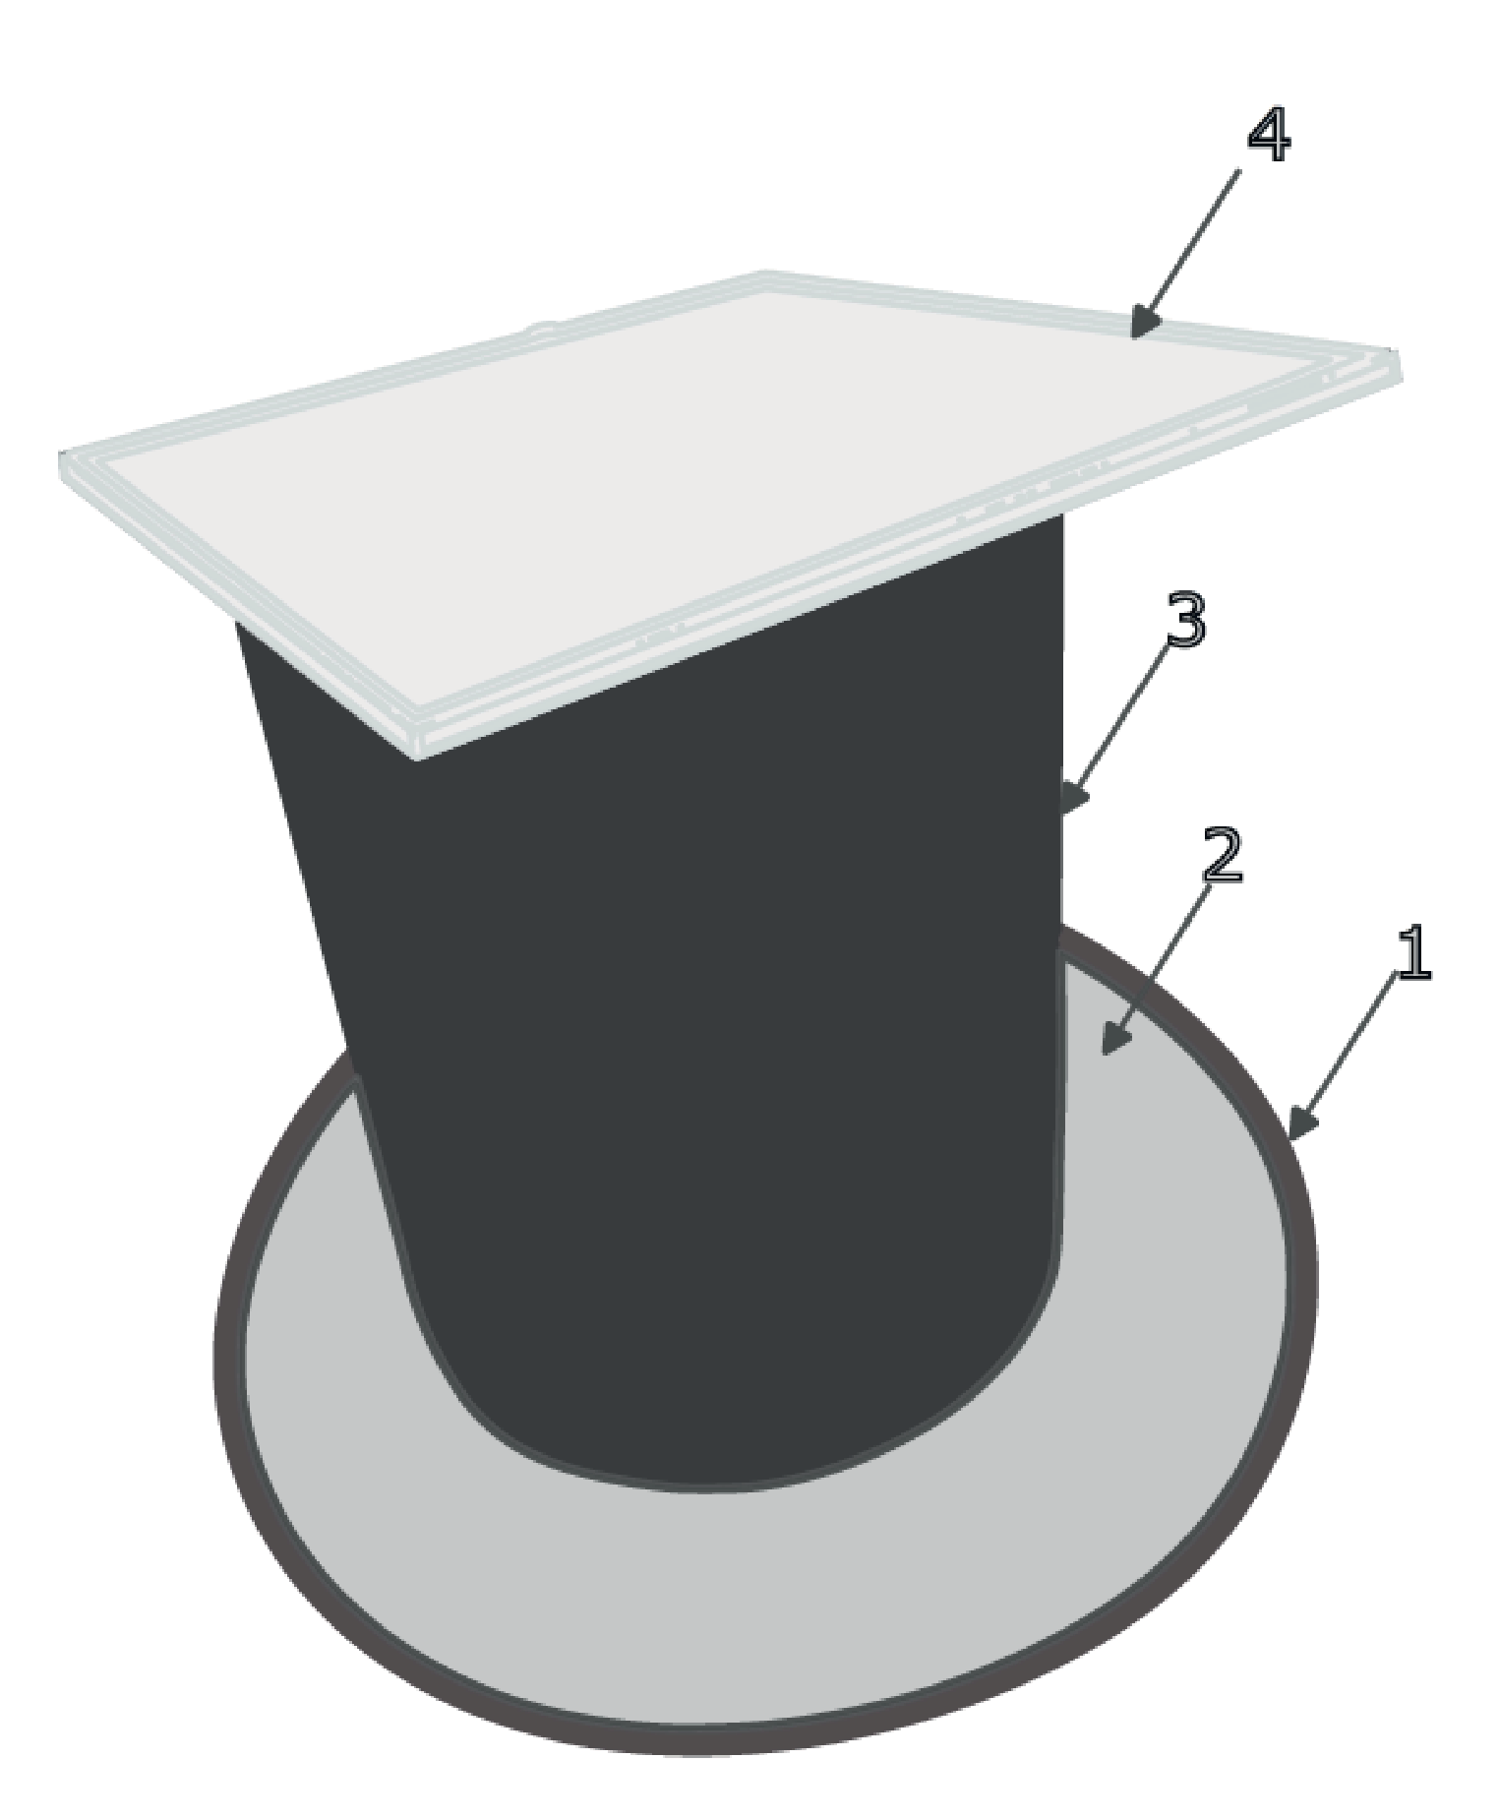
Key
1 | bottom plate
2 | water sealing material
3 | test sample
4 | top plate with air sealing material

Figure A.1 — Schematic diagram of Short-term sealing efficiency
A.5.2 Fill the pipe to the brim with test water (A.2.2) at ambient temperature (20 ± 5 °C).
A.5.3 Cover the top of the pipe with a glass top plate (A.3.2) and seal with air tightness sealing material (A.2.3). or use any other suitable method to close the pipe with air tight sealing on both side.
A.5.4 After (24 ± 1) h, dispose of the water, rinse and refill with test water (A.5.2 and A.5.3).
A.5.5 Repeat A.5.4 twice, sampling the water after the third 24 h exposure period.
A.5.6 Determine the pH of the water sample using the pH meter (A.3.3) in accordance with ISO 10523.
- (normative)
Long-term sealing efficiency
  - Principle
The long-term durability of a seal coat, applied to a cement mortar lining, is determined by measuring the sealing efficiency of the seal coat, after exposure to a cycle of swabbing, high velocity flowing water, pressurization and de-pressurization for a period of 3 months.
  - Materials
B.2.1 Test water, shall be the same as that defined for test water in Annex A.
  - Apparatus
All the materials and components of the test pipeline shall be selected so that they do not impact on the performance of the seal coating.
B.3.1 Soft foam swab, bullet shaped, with a nominal density of 25 kg/m³ to 35 kg/m³, and an indentation hardness index (method A of ISO 2439) of (200 ± 50) N. When placed inside the test pipe, the swab shall be of a diameter such that a compression of 15 % to 25 % is achieved.
B.3.2 Pump, capable of pumping to produce a flow velocity of 2 m/s in the test pipes.
B.3.3 Pressure gauge, capable of measuring pressure of at least 6 bar with a minimum readability of 0,5 bar.
B.3.4 Flowmeter or other suitable device, to enable the measurement of a flow velocity of at least 2 m/s with a minimum readability of 0,2 m/s.
B.3.5 Hand pump or other suitable device, to enable pressurization of the test pipeline.
B.3.6 Flow control valve, e.g. gate valve or other suitable device, to enable setting of the flow velocity.
B.3.7 Air bleed valve, to enable the removal of air from the pipeline.
B.3.8 Outlet/inlet valve, to allow the pipeline to be filled with water and drained of water.
B.3.9 Connecting pipeline components, to enable the assembly and restraint of the pipeline.
B.3.10 DN 150 flow development pipes (FDP), a minimum of 500 mm long, to establish uniform flow in the pipeline after a bend.
B.3.11 Accumulator, (optional device) to reduce pressure variations during the test.
B.3.12 Pressure relief valve, (optional device) to prevent over pressurization during the test.
B.3.13 Water cooler, (optional device) to prevent overheating of the water during the test.
  - Preparation of test samples
The test shall be carried out using two nominally 500 mm long, DN 150 seal coated, cement mortar lined, ductile iron pipe samples. These samples shall be cut from two ductile iron pipes taken from normal production batches. Prior to the test, the seal coat and the swab shall be wetted and the swab shall be passed through each of the test samples once.
  - Procedure
B.5.1 Assemble the pipeline to allow water to be re-circulated, under pressure, through the samples in accordance with Figure B.1. Note that the pipe components will need to be held in place to withstand the forces generated by the internal water pressure.
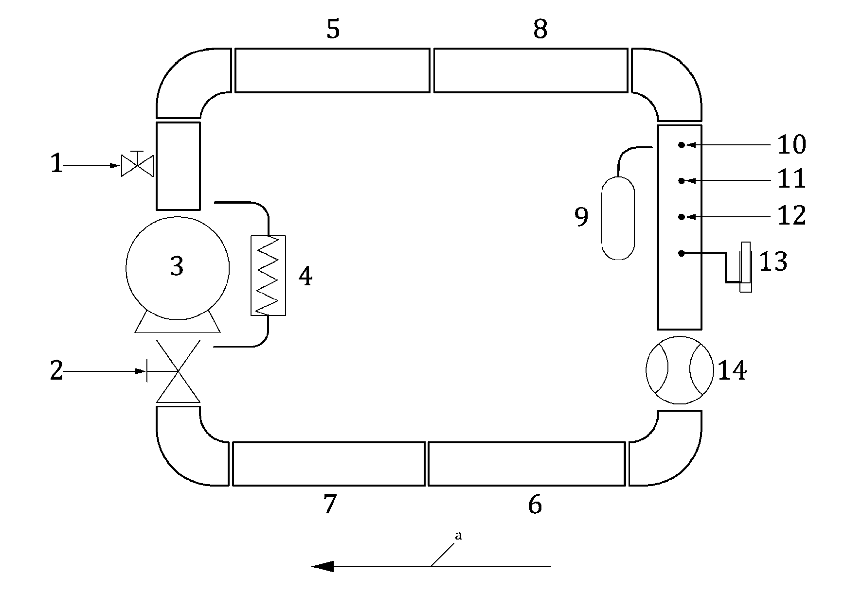
Key
1 | inlet/outlet valve
2 | flow control valve
3 | pump
4 | water cooler (optional)
5, 6 | flow development pipe to assist in developing constant flow (min 500 mm length each)
7, 8 | pipe sample ( 500 mm length each)
9 | accumulator (optional)
10 | pressure relief valve (optional)
11 | pressure gauge
12 | air bleed valve
13 | hand pressure pump
14 | water meter
ª | Direction of flow.

Figure B.1 — Schematic diagram of durability pipeline
Note: the total length of the loop shall be minimised only to the extent that all the items in the assembly are housed adequately and the same shall not affect the pH of the water under test.
B.5.2 Fill the pipeline with the test water and bleed out any entrapped air.
B.5.3 Pump the water in the pipeline up to a minimum pressure of 6 bar ± 1 bar and maintain the pressure for the duration of the test. Note that at the start of the test, small amounts of additional water may need to be added to the pipeline in order to maintain the pressure. The use of an optional accumulator will reduce pressure variations.
B.5.4 Start the pump and increase the flow velocity up to a minimum velocity of 2 m/s ± 0,2 m/s for the duration of the test. The flowmeter may be used to determine the flow velocity by noting the volume of water passing through the pipeline in a set period of time, together with the knowledge of the internal diameter of the test samples. The test is to be conducted at ambient temperature (23 ± 5 °C). The temperature of the water in the pipeline may increase significantly due to the heat from the pump. To prevent this some of the water can be passed through a cooler (as shown in Figure B.1).
B.5.5 After one month of operation stop the flow, de-pressurize the pipeline, drain and discard the water, and remove the test samples. Wet the seal coat and the swab, then pass the swab once through each of the test samples.
B.5.6 Repeat steps B.5.1 to B.5.5 a further two times to complete 3 months of exposure.
B.5.7 Assess the sealing efficiency of the test samples, after the 3-month exposure, by testing each sample in accordance with Annex A.
- (normative)
Cyclic pressure test
  - Principle
The cyclic pressure test is determined as a measure of the durability of a seal coat, applied to a cement mortar lining, when subjected to water contact and cyclic pressurization and de-pressurization.
  - Apparatus and material
C.2.1 Test media, potable water.
C.2.2 Hand pump or alternative device, to enable pressurization of the test pipe.
C.2.3 Inlet valve, to allow the pipe to be filled with water and pressurization.
C.2.4 Air bleed valve, to enable the removal of air from the pipe and de-pressurization.
C.2.5 Pressure gauge, capable of measuring pressure of at least 25 bar with a minimum discrimination of 0,5 bar.
C.2.6 Connecting pipe components, to enable the assembly and restraint of the pipe. For example, socket plug, spigot plug and support structure for restrain the pipe during pressurization.
  - Sample preparation
The test shall be carried out using two nominally 500 mm long, DN 150 seal coated, cement mortar lined, ductile iron pipe samples. These samples shall be cut from two ductile iron pipes taken from normal production batches ensuring that the seal coat is completely dry/cured before test.
  - Procedure
C.4.1 Test temperature, the test shall be carried out at ambient temperature.
C.4.2 Assembly, assemble test components in accordance with Figure C.1.
NOTE The pipe components need to be held in place to withstand the forces generated by the internal water pressure.
C.4.3 Preparation, fill the pipe with potable water and bleed out any entrapped air, and soak for 24 h.
C.4.4 Pressurization and retention, pump the water pressure up to 16 bar to 18 bar, and maintain it in that range for 2 h. During the maintenance period, continuously monitor the pressure in the pipes, and re-pressure as required.
C.4.5 De-pressurization, after 2 h, de-pressurize the pipe to 0 bar at a rate within the range of 0,5 bar to 1,0 bar/s and maintain at 0 bar for 2 h.
C.4.6 Cycle, C.4.4 to C.4.5 is one cycle. Repeat that cycle to achieve a total of 25 cycles.
C.4.7 Inspection, after 25 cycles, disassemble the components and visually inspect the seal coat immediately using a light source to illuminate the seal coat along the full length of the sample to determine if there is any peeling of the seal coat or cracking in excess of 0,8 mm in width.
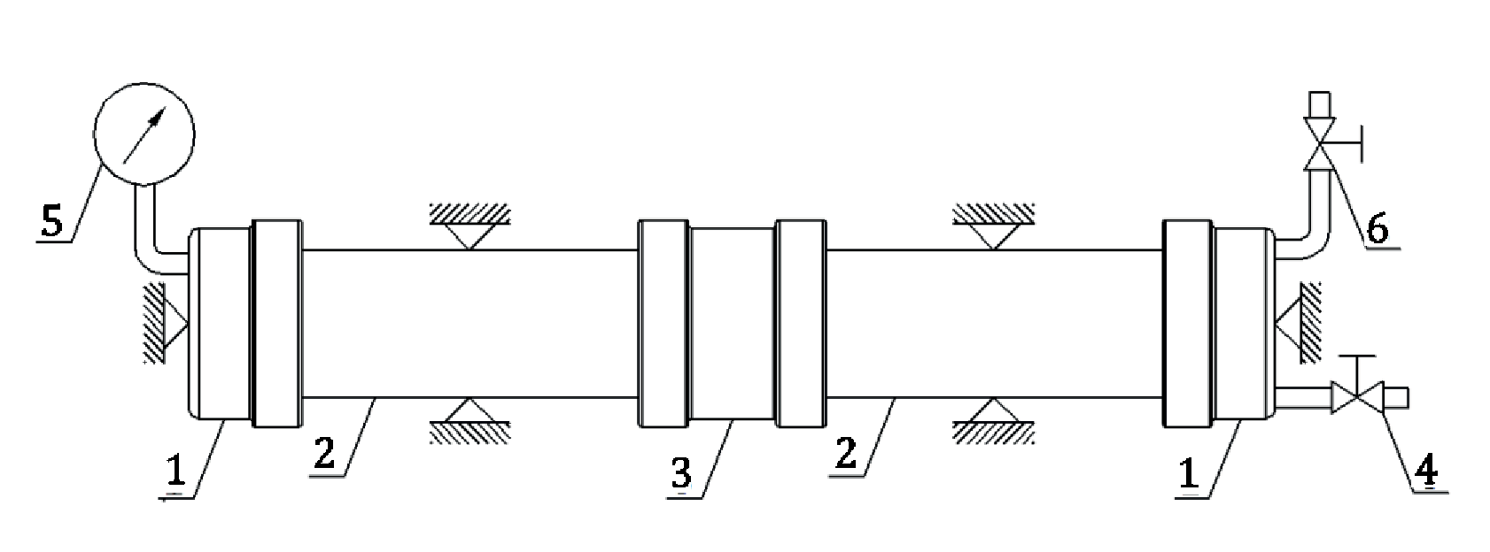
Key
1 | end caps
2 | pipe samples
3 | pipe joiner
4 | inlet valve
5 | pressure gauge
6 | outlet valve/air bleed

Figure C.1 — Schematic diagram of cyclic pressure test assembly
- (normative)
Coating thickness measurement using test film
  - Principle
The average thickness of dry coating on a test film is determined to within 5 µm either by using a micrometer or by using a weight and area method.
  - Apparatus
D.2.1 Test film, of known thickness and mass/unit area, and having a minimum area of 5 000 mm² (0,005 0 m²).
D.2.2 Micrometer, having the capacity to measure to at least 10 mm, with a resolution of 5 µm or less.
D.2.3 Tape measure, at least 1m in length, with a resolution of 1 mm or less.
D.2.4 Analytical balance, having at least 200 g capacity and a resolution of 0,01 g or less.
  - Preparation of test samples
D.3.1 Immediately prior to applying the seal coating, attach the piece of test film to the surface of the lining using self-adhesive tape.
The test film may be attached to the surface by applying tape to two edges of the film.
D.3.2 After applying the seal coating, remove the test film. Allow the coating on the film to dry/cure.
D.3.3 When the coating on the film is dry/cured, determine the dry film thickness using one or both of the methods D.4 or D.5.
  - Micrometer measurement method
D.4.1 Procedure
D.4.1.1 Select positions on the test film, where readings are to be taken, which are free from surface irregularities and are not less than 20 mm from the coated test film edge and not less than 20 mm apart.
For large areas of coated test film, select the number and distribution of the test areas to give a representative indication of the coated film thickness.
D.4.1.2 Position the micrometer (D.2.2) with its fixed jaw in contact with the coated side of the coated test film at the first test area. Gently screw home its movable jaw until a resistance is felt and no further movement of the jaw occurs on turning the ratchet.
Note the reading on the micrometer. Record the reading on a test sheet.
D.4.1.3 Release the micrometer and repeat the whole procedure in D.4.1.2, at each of the other test positions.
D.4.2 Calculation
NOTE Alternatively, the measurement can be done by means of suitable digital coating thickness gauge.
D.4.2.1 Calculate the film thickness at each point by subtracting the mean thickness of the test film from each thickness reading.
The mean thickness of the test film, if unknown, may be determined in accordance with D.4.1.2, using an un-coated test film sample, taking the average of at least 10 readings.
D.4.2.2 Calculate the mean value for the thickness of the coating to the nearest multiple of 5 µm or less (depending upon the accuracy of the micrometer).
  - Weight and area method — Procedure
D.5.1 In order to produce a rectangular sample, cut away areas of the coated test film which have adhesive tape attached.
D.5.2 Using a tape measure (D.2.3), measure the width and length of the test film to an accuracy of ±1 mm, and then calculate the film area, A, in square metres (m²) to five decimal places.
D.5.3 Record the weight of the uncoated test film, W, in grams (g) to four significant figures using the balance (D.2.4).
D.5.4 Record the weight of the coated test film, G, in grams (g) to four significant figures using the balance (D.2.4).
D.5.5 Determine the coating thickness, T, in micrometres (µm), using Formula (D.1):
(D.1)
where D is the density of the dried/cured coating in grams per cubic centimetre (g/cm³).
- (normative)
Adhesion test
  - Principle
The adhesion of a seal coat to a cement mortar substrate is assessed by applying and removing adhesive tape. For seal coats with a specified minimum thickness of greater than 100 µm, a cross cut is made in the film before application of the adhesive tape. For seal coats with a specified minimum thickness of less than or equal to 100 µm, the adhesive tape is applied directly to the seal coat.
  - Apparatus
E.2.1 Cutting tool, e.g. sharp bladed knife, scalpel, high-speed micro-abrasive disc, or other cutting device.
E.2.2 Cutting guide, e.g. steel or other hard metal straight edge to ensure straight cuts.
E.2.3 Soft brush, for removing debris from the cut area.
E.2.4 Light source, to assist in determining whether the cuts have been made through the film to the substrate.
E.2.5 Adhesive tape, 25 mm to 50 mm wide with a minimum peel adhesion strength of 0,35 N/mm width when measured in accordance with ASTM D3330, Test method A.
  - Procedure
E.3.1 Select an area of seal coated surface and ensure that it is clean and dry.
E.3.2 Where applicable (see E.1) using the cutting tool (E.2.1) with the straight edge (E.2.2) as a guide, in one steady motion, make two cuts in the film, each approximately 50 mm long, which intersect near their middle with a smaller angle of between 30° and 45°. Remove any cutting debris using a soft brush (E.2.3). Using the light source (E.2.4), inspect the incisions to establish that the coating film has been penetrated. If not, repeat E.3.2.
E.3.3 Remove a length of adhesive tape (E.2.5) at least 75 mm long from the roll. Smooth the tape into place using finger pressure. Where a cross cut is used, place the centre of the tape at the intersection of the cuts in the same direction as the smaller angles. Smooth the tape into place using finger pressure in the area of the incisions.
E.3.4 Within (60 ± 30) s of application, remove the tape by grasping the free end and slowly pull it back on itself, without jerking, at an angle of approximately 180° to the plane of the seal coated lining.
E.3.5 Inspect the area of the tape for removal of seal coat from the mortar substrate. Only coating removed by adhesive failure of the bond between the seal coat and the mortar shall be considered in the assessment. Coating removed by cohesive failure, either within the seal coat or within the mortar (shown by a white/grey layer on the underside of the tape), shall not be considered in the assessment.
E.3.6 If a cross cut is used, determine the adhesion in terms of the following scale, as defined in Annex A, BS EN ISO 16276 - 2:
1) Level 0: no peeling or removal of seal coat;
2) Level 1: trace peeling or removal along cuts or at their intersection;
3) Level 2: jagged removal of seal coat along cuts, extending upto 1,5 mm out on either side;
4) Level 3: jagged removal of seal coat along most of the length cuts, extending upto 3,0 mm on either side;
5) Level 4: removal from most of the area of the X-cut under the tape;
6) Level 5: removal of seal coat beyond the area of the X-cut.
E.3.7 If no cross cut is used, determine the total area of disbonded coating as a percentage of the total area of coating originally covered by the adhesive tape.
- (normative)
Quality assurance
  - General
The manufacturer should demonstrate the conformity of the product with this document by carrying out performance tests in accordance with Table F.1 and routine tests in accordance with Table F.2.

Table F.1 — Performance tests
No. | Test | Requirements | Test Methods/reference clause
1 | Materials in contact with potable water | National standards | Clause no. 4.0
2 | Short-term sealing efficiency | As per clause no. 5.1 | Annex A
3 | Long-term sealing efficiency | As per clause no. 5.2 | Annex B
4 | Cyclic pressure | As per clause no. 5.3 | Annex C

Table F.2 — Routine tests
No. | Test | Requirements | Test Methods/reference clause
1 | General | As per clause no. 6.1 | -
2 | Visual appearance | As per clause no. 6.2 | -
3 | Coating thickness | As per clause no. 6.3 | Annex D
4 | Adhesion | As per Clause no. 6.4 | Annex E

Bibliography
[1] ISO 2531, Ductile iron pipes, fittings, accessories and their joints for water applications

